**Module V**

**Pyrometers**

**Types of Pyrometers**

To detect the different object’s temperature, pyrometers are classified into 2 types. They are,

* Optical Pyrometers
* Infrared / Radiation pyrometers

Optical Pyrometer

**Definition:** The optical pyrometer is a non-contact type temperature measuring device. It works on the principle of matching the brightness of an object to the brightness of the filament which is placed inside the pyrometer. The optical pyrometer is used for measuring the temperature of the furnaces, molten metals, and other overheated material or liquids.

It is not possible to measures the temperature of the highly heated body with the help of the contact type instrument. Hence the non-contact pyrometer is used for measuring their temperature.

Construction of Optical Pyrometer

The construction of the optical pyrometer is quite simple. The pyrometer is cylindrical inside which the lens is placed on one end and the eyepiece on the other end. The lamp is kept between the eyepiece and the lens. The filter is placed in front of the eyepiece. The filter helps in getting the monochromatic light. The lamp has the filament which is connected to the battery,[ammeter](https://circuitglobe.com/ammeter.html) and the rheostat.

Working of Optical Pyrometer

The optical pyrometer is shown in the figure below. It consists the lens which focuses the radiated energy from the heated object and targets it on the electric filament lamp. The intensity of the filament depends on the current passes through it. Hence the adjustable current is passed through the lamp.

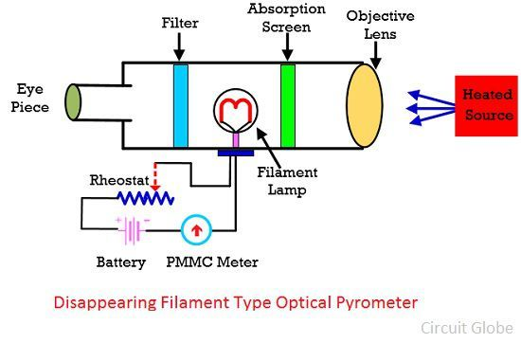

The magnitude of the current is adjusted until the brightness of the filament is similar to the brightness of the object. When the brightness of the filament and the brightness of the object are same, then the outline of the filament is completely disappeared.

[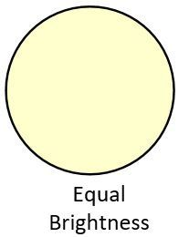](https://circuitglobe.com/wp-content/uploads/2018/04/optical-pyrometer-image-3.jpg)

The filament looks bright when their temperature is more than the temperature of the source.

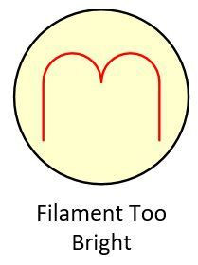

The filament looks dark if their temperature is less than that required for equal brightness

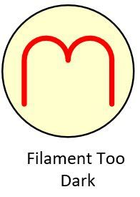

Advantages of Optical Pyrometer

* The optical pyrometer has high accuracy.
* The temperature is measured without contacting the heated body. Because of this property, the pyrometer is used for the number of applications.

Disadvantages of Optical Pyrometer

The working of the pyrometer depends on the intensity of light emitted by the heated body. Thereby, the pyrometer is used for measuring the temperature having a temperature more than 700-degree Celsius. The accuracy of the pyrometer depends on the adjustment of the filament current. Also, the pyrometer is not used for measuring the temperature of clean gases.

<https://instrumentationtools.com/optical-pyrometer-working-principle/>

**Radiation Pyrometer Working Principle**

As discussed earlier, an [Optical Pyrometer](https://instrumentationtools.com/optical-pyrometer-working-principle/) can be not only be used for temperature measurement, but also can be used to see the heat that is measured. The observer is actually able to calculate the infrared wavelength of the heat produced and also see the heat patterns by the object. But the amount of heat that the device can sense is limited to 0.65 microns. This is why the radiation pyrometer is more useful, as it can be used to measure all temperatures of wavelengths between 0.70 microns and 20 microns.

**Radiation Pyrometer**

The wavelengths measured by the device are known to be pure radiation wavelengths, that is, the common range for radioactive heat. This device is used in places where physical contact temperature sensors like Thermocouple, RTD, and Thermistors would fail because of the high temperature of the source.

The main theory behind a radiation pyrometer is that the temperature is measured through the naturally emitted heat radiation by the body. This heat is known to be a function of its temperature. According to the application of the device, the way in which the heat is measured can be summarized into two:

1. **Total Radiation Pyrometer** – In this method, the total heat emitted from the hot source is measured at all wavelengths.
2. **Selective Radiation Pyrometer** – In this method, the heat radiated from the hot source is measured at a given wavelength.

As shown in the figure below, the radiation pyrometer has an optical system, including a lens, a mirror and an adjustable eye piece. The heat energy emitted from the hot body is passed on to the optical lens, which collects it and is focused on to the detector with the help of the mirror and eye piece arrangement. The detector may either be a thermistor or photomultiplier tubes. Though the latter is known for faster detection of fast moving objects, the former may be used for small scale applications. Thus, the heat energy is converted to its corresponding electrical signal by the detector and is sent to the output temperature display device.

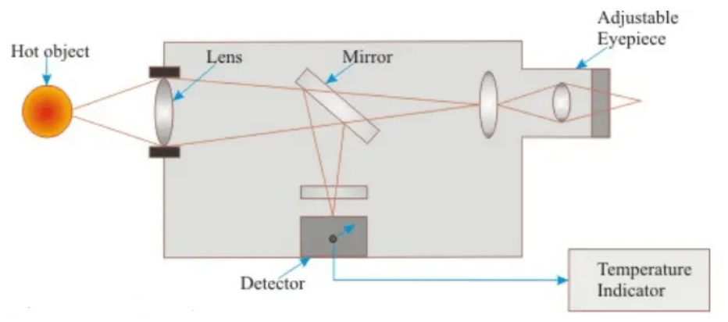

**Advantages**

* The device can be used to measure very high temperatures without direct contact with the hot source (Molten metal).
* The biggest advantage is that the optical lens can be adjusted to measure temperature of objects that are even 1/15 inch in diameter and that too kept at a long s=distance from the measuring device.
* The sight path of the device is maintained by the construction of the instrument components, such as the lens and curved mirrors.

**Limitations**

* Availability of optical materials limit on the wavelengths that can be measured.
* The surface of the hot object should be clean. It should not be oxidized. Scale formation does not allow to measure radiation accurately.
* Emissivity correction is required. Change in emissivity with temperature need to be considered.

**Total Radiation Pyrometer – Diagram, Working, Advantages**

Thermal radiation is an electromagnetic radiation emitted by a body as a result of its temperature. Thermal radiation is in the wavelength region from about 0.1-100 µm.

The total radiation emitted by a blackbody is given by , Eb = σ x T ^4

**where**

* σ  is the Stefan Boltzmann constant (5.669 x 10^-8 W/m^2 y,
* Eb is the emissive power, and
* T is the absolute temperature in K.

**Construction:**

The total radiation of pyrometer has one housing tube in which an adjustable eye piece is fixed at one end of the housing tube and the other end is free to receive radiations from the radiating object whose temperature is to be measured. A rack and pinion attachment is used to adjust the position of a concave mirror (Figure). A thermocouple is also provided to receive the radiation and the thermocouple is  
connected to the milli voltmeter to measure the temperature.

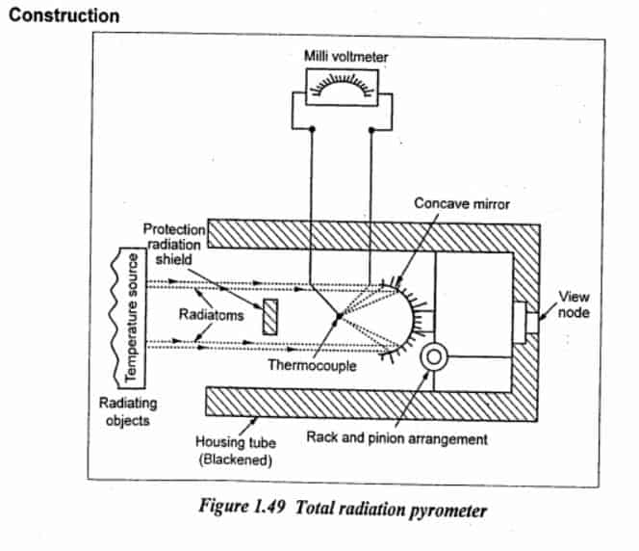

**Working**

Thermal radiations from the radiating object come inside the housing tube. These radiations fall on the concave mirror and they are reflected to the hot junction of the thermocouple. So, an e.m.f. will be produced in the thermocouple and it is measured by using a milli voltmeter. This change in e.m.f. will give the measure of temperature.

***Application***

* It is used to measure the high temperature of 3500°C.

**Advantages**

1. It has high accuracy
2. There is no physical contact with the radiating object
3. The distance between radiating object and pyrometer is negligible

**Disadvantages**

1. It is not suitable for very low temperature measurement due to poor sensitivity.  
   2. Dust, smoke, gases in between radiating object and instrument will cause error.

<https://learnmech.com/total-radiation-pyrometer-diagram-working-advantages/>

‘

<https://www.eeeguide.com/pyrometer-working-principle/>

**Difference between radiation pyrometer and optical pyrometer**

