**Module IV**

**Filled System Temperature Measurement**

Filled-system temperature measurement methods depend upon three well-known physical phenomena:

* A liquid will expand or contract in proportion to its temperature and in accordance to the liquid’s coefficient of thermal/volumetric expansion.
* An enclosed liquid will create a definite vapor pressure in proportion to its temperature if the liquid only partially occupies the enclosed space.

The pressure of a gas is directly proportional to its temperature in accordance with the basic principle of the universal/perfect gas law:  **PV = nRT** where P = absolute pressure, V = volume, T = absolute temperature, R = universal gas constant and n = number of gas particles (moles).

**Description**

All filled-system temperature measurement instruments consists of a bulb, connecting tubing known as “capillary,” and a pressure sensing element, usually a **bourdon tube**.  All commercially available filled system thermometers have been classified by **ASME B40.200 (ASME B40.4).**  The standard classifies filled-system thermometers by the type of fill fluid used (liquid, vapor, gas) and further subdivided by the type of temperature compensation.  The different types of filled systems are identified by “Class Numbers”, ranging from 1 through 5, refer ASME B40.200 for more details.

**Bulb Design**

Different bulb materials are available. standard material such as **copper, bronze, or stainless steel** can be used. In case   atmospheric corrosion, Stainless steel is preferred. If a well is not used (not recommended), the bulb must suitable for process fluid.

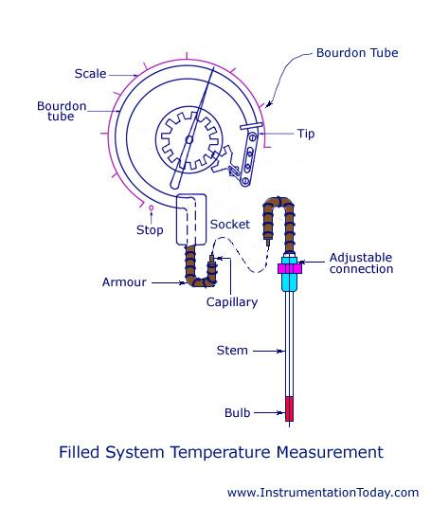

**Capillary Tubing & Armoring**

Capillary tubing is small-diameter tubing, usually of stainless steel. Armor should always be specified not to provide only mechanical strength but also distinguish with other tubing. Armor material shall be stainless steel. However in a corrosive atmosphere, the armor should be plastic coated. The length of capillary shall be carefully selected and specified so that instrument can be installed as per requirement, since it cannot be stretched or spliced.

Four types of filled bulb temperature sensors

1. Liquid Filled (Class I A,B)
2. Vapor filled (Class II A,B,C,D)
3. Gas Filled (Class III A,B)
4. Mercury Filled (Class V A,B)

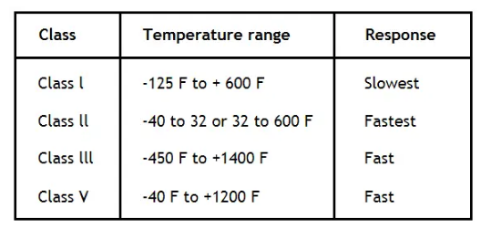

Class I and Class V systems use a liquid fill fluid (class V is mercury). Here, the volumetric expansion of the liquid drives an indicating mechanism to show temperature:

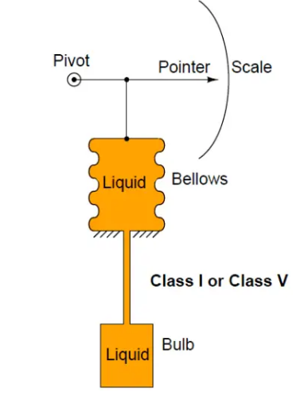

Class III systems use a gas fill fluid instead of liquid. Here, the change in pressure with temperature (as described by the Ideal Gas Law) allows us to sense the bulb’s temperature:

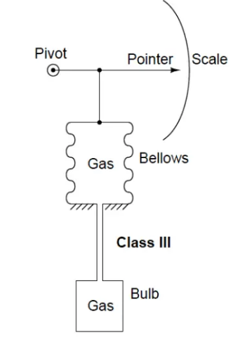

In these systems, it is quite critical that the tube connecting the sensing bulb to the indicating element be of minimal volume, so the fluid expansion is primarily due to changes in temperature at the bulb rather than changes in temperature along the length of the tube. It is also important to realize that the fluid volume contained by the bellows (or bourdon tube or diaphragm . . .) is also subject to expansion and contraction due to temperature changes at the indicator.

# Thermocouple

A thermocouple is made up of two dissimilar metals, joined together at one end, that produce a voltage (expressed in millivolts) with a change in temperature. The junction of the two metals, called the sensing junction, is connected to extension wires. Any two dissimilar metals may be used to make a thermocouple.

P**rinciple of Operation**

* When two dissimilar metals are connected together, a small voltage called a *thermo-junction voltage* is generated at the junction. This is called the ***Peltier effect***.
* If the temperature of the junction changes, it causes voltage to change too, which can be measured by the input circuits of an electronic controller. The output is a voltage proportional to the temperature difference between the junction and the free ends. This is called the ***Thompson effect***.
* Both of these effects can be combined to measure temperature. By holding one junction at a known temperature (reference junction) and measuring the voltage, the temperature at the sensing junction can be deduced. The voltage generated is directly proportional to the temperature difference. The combined effect is known as the *thermo-junction effect* or the ***Seebeck effect***.

Figure right side illustrates a simple thermocouple circuit.

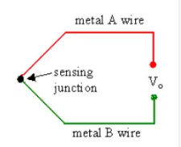

The voltage is measured to infer the temperature. In practical operation, wires A and B are connected to a digital voltmeter (DVM), digital multimeter (DMM), digital data acquisition system, or some other voltage measuring device. If the measuring device has very high input impedance, the voltage produced by the thermo-junction can be measured accurately.

However, the main problem with thermocouple temperature measurement is that wires A and B must connect to the leads of the voltmeter, which are generally made of copper. If neither wire A nor wire B is itself copper, connecting to the DVM creates *two more thermo-junctions*! (Thermocouple metals are typically not the same as those of the DVM leads.) These additional thermo-junctions also produce a thermo-junctive voltage, which can create an error when trying to measure the voltage from the sensing junction.

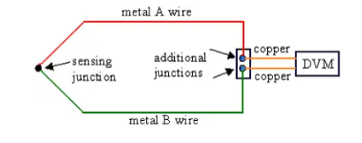

***How can this problem be resolved?***

One simple solution is to add a fourth thermo-junction, called a *reference junction*, by inserting an additional length of metal A wire into the circuit as sketched below. The reference junction consists of metals A and B as indicated on the sketch.

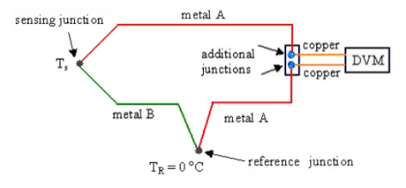

**This modified circuit is analyzed as follows:**

With this arrangement, there are still two additional thermocouple junctions formed where the compensated thermocouple is connected to the voltmeter (DVM). The two junctions to the DVM are now both between metal A and copper. These two junctions are placed *close together* , and at the *same* *temperature*, so that their thermo-junction voltages are identical, and cancel each other out. Meanwhile, the new reference junction is placed in a location where the *reference temperature* TR is known accurately, typically in an ice-water bath with a fixed temperature of T R = 0°C. If the sensing junction is also at 0°C (Ts = 0 oC), the voltage generated by the sensing junction will be equal and opposite of that generated by the reference junction. Hence, Vo = 0 when Ts = 0°C. However, if the sensing junction temperature is not equal to TR, Vo will be non-zero.

**Thermocouple Materials**

Thermocouples may be constructed of several different combinations of materials. The performance of a thermocouple material is generally determined by using that material with platinum. The most important factor to be considered when selecting a pair of materials is the “thermoelectric difference” between the two materials. A significant difference between the two materials will result in better thermocouple performance.

Figure below illustrates the characteristics of the more commonly used materials when used with platinum. For example: Chromel-Constantan is excellent for temperatures up to 2000°F; Nickel/Nickel- Molybdenum sometimes replaces Chromel- Alumel; and Tungsten-Rhenium is used for temperatures up to 5000°F. Some combinations used for specialized applications are Chromel-White Gold, Molybdenum-Tungsten, Tungsten-Iridium, and Iridium/Iridium-Rhodium.

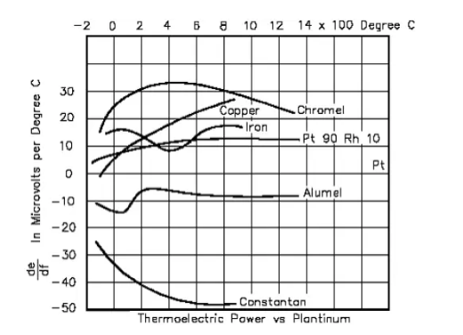

Most of these thermocouple types are known by a single-letter designation; the most common are J, K, T, and E. The compositions of thermocouples are international standards, but the color codes of their wires are different. For example, in the U.S. the negative lead is always red, while the rest of the world uses red to designate the positive lead. Often, the standard thermocouple types are referred to by their trade names. For example,

* A ***type K*** thermocouple has the color *yellow*, and uses *chromel* – *alumel,* which are the trade names of the Ni-Cr and Ni-Al wire alloys.
* A ***type J*** thermocouple has the color *black*, and uses *iron* and *constantan* as its component metals. (Constantan is an alloy of nickel and copper.)
* A ***type T*** thermocouple has the color *blue*, and uses *copper* and *constantan* as its component metals.
* A **type S** thermocouple uses Pt/Rh-Pt
* A **type E** thermocouple uses Ni/Cr-Con
* *A****type N****thermocouple uses Ni/Cr/Si-Ni/Si*

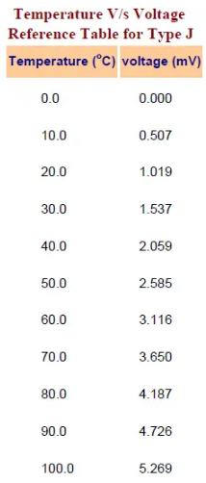

**Choosing a thermocouple type**

Because thermocouples measure in wide temperature ranges and can be relatively rugged, they are very often used in industry.

The following criteria are used in selecting a thermocouple:

1. Temperature range.
2. Chemical resistance of the thermocouple or sheath material.
3. Abrasion and vibration resistance.
4. Installation requirements (may need to be compatible with existing equipment; existing holes may determine probe diameter).

**Resistance Temperature Detector or RTD | Construction and Working Principle**

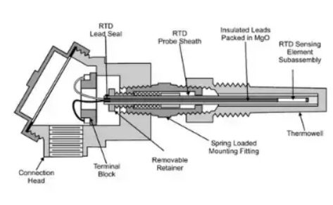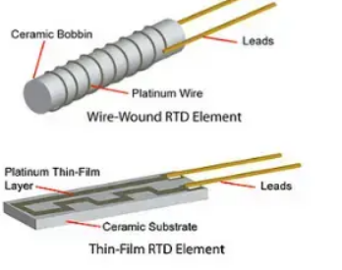

A **Resistance Temperature Detector** (also known as a **Resistance Thermometer** or **RTD**) is an electronic device used to determine the temperature by measuring the [resistance](https://www.electrical4u.com/electrical-resistance-and-laws-of-resistance/) of an electrical wire. This wire is referred to as a temperature sensor. If we want to measure temperature with high accuracy, an **RTD** is the ideal solution, as it has good linear characteristics over a wide range of temperatures. Other common electronics devices used to measure temperature include a [thermocouple](https://www.electrical4u.com/thermocouple/) or a [thermistor](https://www.electrical4u.com/thermistor/).

The variation of resistance of the metal with the variation of the temperature is given as,



Where, Rt and R0 are the resistance values at toC and t0oC temperatures. α and β are the constants depends on the metals.

This expression is for huge range of temperature. For small range of temperature, the expression can be,  


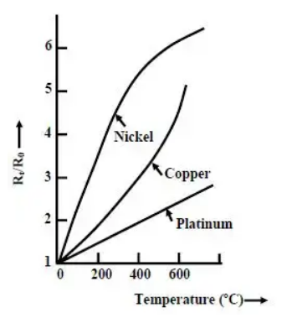

In **RTD** devices; Copper, Nickel and Platinum are widely used metals. These three metals are having different resistance variations with respective to the temperature variations. That is called resistance-temperature characteristics.

Platinum has the temperature range of 650oC, and then the Copper and Nickel have 120oC and 300oC respectively. The figure-1 shows the resistance-temperature characteristics curve of the three different metals. For Platinum, its resistance changes by approximately 0.4 ohms per degree Celsius of temperature.

The purity of the platinum is checked by measuring R100 / R0. Because, whatever the materials actually we are using for making the RTD that should be pure. If it will not pure, it will deviate from the conventional resistance-temperature graph. So, α and β values will change depending upon the metals.

**Construction of Resistance Temperature Detector or RTD**

The construction is typically such that the wire is wound on a form (in a coil) on notched mica cross frame to achieve small size, improving the thermal conductivity to decrease the response time and a high rate of heat transfer is obtained. In the industrial RTD’s, the coil is protected by a stainless steel sheath or a protective tube.

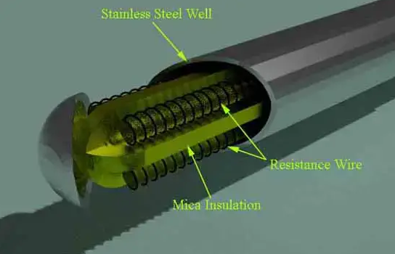

So that, the physical strain is negligible as the wire expands and increase the length of wire with the temperature change. If the strain on the wire is increasing, then the tension increases. Due to that, the resistance of the wire will change which is undesirable. So, we don’t want to change the resistance of wire by any other unwanted changes except the temperature changes.  
This is also useful to RTD maintenance while the plant is in operation. Mica is placed in between the steel sheath and resistance wire for better electrical insulation. Due less strain in resistance wire, it should be carefully wound over mica sheet. The fig.2 shows the structural view of an Industrial Resistance Temperature Detector.

We can get this RTD in market. But we must know the procedure how to use it and how to make the signal conditioning circuitry. So that, the lead wire errors and other calibration errors can be minimized. In this RTD, the change in resistance value is very small with respect to the temperature.

So, the RTD value is measured by using a bridge circuit. By supplying the constant [electric current](https://www.electrical4u.com/electric-current-and-theory-of-electricity/) to the bridge circuit and measuring the resulting [voltage](https://www.electrical4u.com/voltage-or-electric-potential-difference/) drop across the [resistor](https://www.electrical4u.com/types-of-resistor/), the RTD resistance can be calculated. Thereby, the temperature can be also determined. This temperature is determined by converting the RTD resistance value using a calibration expression. The different modules of RTD are shown in below figures.  
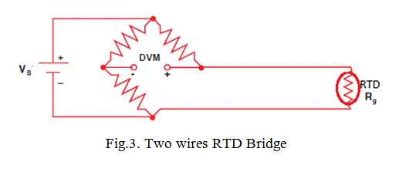

In two wires RTD Bridge, the dummy wire is absent. The output taken from the remaining two ends as shown in fig.3. But the extension wire resistances are very important to be considered, because the impedance of the extension wires may affect the temperature reading. This effect is minimizing in three wires RTD bridge circuit by connecting a dummy wire C.

If wires A and B are matched properly in terms of length and cross section area, then their impedance effects will cancel because each wire is in opposite position. So that, the dummy wire C acts as a sense lead to measure the [voltage drop](https://www.electrical4u.com/voltage-drop-calculation/) across the RTD resistance and it carries no current. In these circuits, the output voltage is directly proportional to the temperature. So, we need one calibration equation to find the temperature.

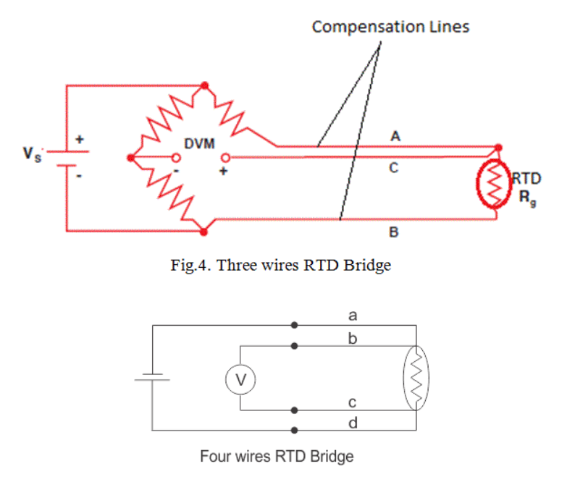

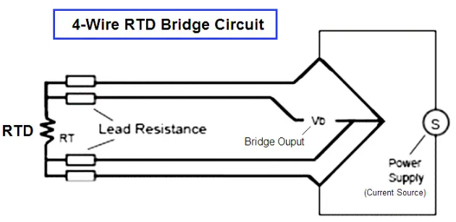

The most accurate lead wire configuration is the “true” 4-wire configuration. One set of wires delivers the current used for measurement, and the other set measures the voltage drop over the resistor.

**Limitations of RTD**

In the RTD resistance, there will be an I2R power dissipation by the device itself that causes a slight heating effect. This is called as self-heating in RTD. This may also cause an erroneous reading. Thus, the [electric current](https://www.electrical4u.com/electric-current-and-theory-of-electricity/) through the **RTD** resistance must be kept sufficiently low and constant to avoid self-heating.

**What is the difference between RTD and thermocouples?**

There are a number of differences between[thermocouples](https://peaksensors.co.uk/blog/what-is-thermocouple-how-does-it-work/) and RTD sensors. Below we have outlined the main ones.

1. [Thermocouples](https://peaksensors.co.uk/thermocouples/cable-thermocouples/) are usually smaller than RTDs, making them easier to use.
2. Thermocouples (-200 to 2000°C) offer a wider range of temperature operation than RTDs (-200 to 600° C). This means that thermocouples are suitable for more applications.
3. [Thermocouples](https://peaksensors.co.uk/thermocouples/mineral-insulated-thermocouples/) offer a response time between 0.1 and 10s which is faster than the response time of RTD sensors~~.~~
4. RTDs can self-heat while this issue is negligible with the [thermocouples](https://peaksensors.co.uk/thermocouples/rare-metal-thermocouples/).
5. Thermocouples are more sensitive than RTD temperature sensors. This is so because these react faster than RTDs with the variation in temperature.
6. For [thermocouples](https://peaksensors.co.uk/thermocouples/base-metal-thermocouples/), the graph between resistance and temperature is not linear, while an RTD is linear.

<https://youtu.be/yNryBIe5kEg>

<https://youtu.be/WNs8FBl3c7M>

**Cold junction compensation**

Cold junction compensation is a process whereby a voltage is added (or subtracted) from the output voltage of the thermocouple so that the reference junction appears to be at 0 °C even if it is not.

For a [Thermocouple](https://instrumentationtools.com/thermocouple-applications/), Temperature should be measured with the cold junction at 0°C or 32°F (At thermocouple terminated side i.e. transmitter).

Meaning that we have to maintain 0°C or 32°F at temperature transmitter terminals which is practically not possible. so compensation is required to correct the measured temperature reading.  
When a thermocouple or its extension wires are connected to the terminals of a device like a thermocouple transmitter the cold junction is at the room temperature T1°C.

If both temperatures of the hot and the cold junctions are above 0°C, the device receives a lower emf than when the cold junction temperature is 0°C.

In order to measure the temperature accurately, we need to add the emf value which corresponds to T1 to the measured emf. To add this emf is called cold junction compensation.

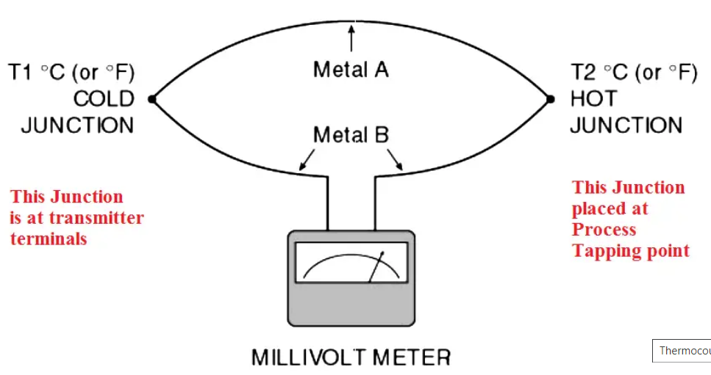

The figures show the temperature-emf curve (not to scale) and a temperature measuring setup with a thermocouple and a millivolt meter. Assume the cold and the hot junctions are at T1°C and T2°C, respectively.

According to the temperature-emf table of the standard, the thermocouple generates emf of E1 mV at the temperature T1 and E2 mV at T2. The millivolt meter receives the potential difference, E2 – E1 which corresponds to T2 – T1.

In order to obtain T2, we need to add E1 to the potential difference, E2 – E1 for elimination of E1.

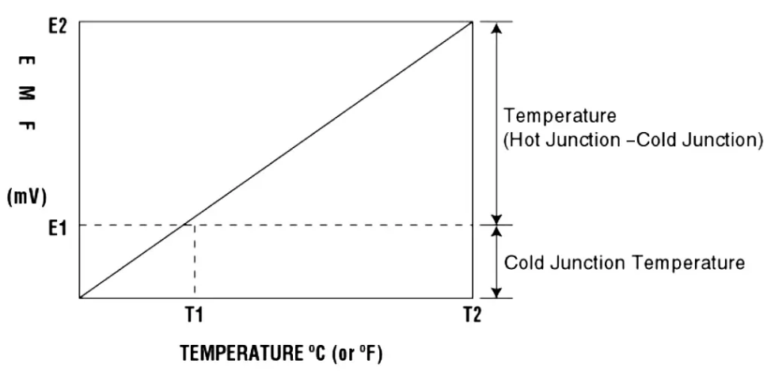

An actual example may better clarify the above discussion. Assume that we are using a [Type E thermocouple](https://instrumentationforum.com/t/type-e-thermocouple-nickel-chromium-constantan/4095) to measure T2 (say process temperature), which is 550°C (1022°F). Now the another thermocouple junction T1 say which is terminated at temperature transmitter or in control room & T1 temperature is at room temperature which is 25°C (77°F)

According to the temperature-emf table of Type E, the thermocouple generates (with reference to °C):

Process temperature (T2) is 550°C and so as per Type E thermocouple table or measured voltage is : 41. 045 mV at 550°C

Now room temperature (T1) is 25°C and so as per Type E thermocouple table or measured voltage is : 1.495 mV at 25°C

The potential difference is 39.550 mV.

The [thermocouple type](https://instrumentationtools.com/types-of-thermocouples/) temperature transmitter displays the temperature value based on 39.55 mV which is equivalent to 531.5°C. But actual process temperature is 550°C, so there is 18.5°C error exists (Error=550-531.5).

This temperature error will be compensated using cold junction compensation technique.

In Cold junction compensation, we place a temperature sensor near the [temperature transmitter](https://instrumentationtools.com/cascade-temperature-control-system/) terminals (if thermocouple terminated in field) or at control room terminations  (if thermocouple terminated in control room) then this temperature sensor measures the room temperature T1 value say 1.495 mV @ 25°C.

Now this measured milli volt will be added to the already measured potential difference value i.e. 39.55 mV, so 39.55mV + 1.495mV = 41.045 mV, so temperature transmitter shows compensated corrected temperature reading.