**Module III**

**Electronic Pressure Sensor with Bourdon Tube and LVDT**

A simple form of [electronic pressure sensor](https://instrumentationtools.com/electronic-pressure-sensors-principle/) could be made with a [bourdon tube](https://instrumentationtools.com/bourdon-tube-pressure-gauge/) and a Linear Variable Differential Transformer, or [LVDT](https://instrumentationforum.com/t/explain-working-of-lvdt/284).

Note very carefully how the two secondary coils are connected in series-opposing (as denoted by the phase dots)! This detail is essential in figuring out how the LVDT works.

The output is an AC voltage, the magnitude of which is proportional to core position, which in turn is proportional to applied [pressure](https://instrumentationtools.com/top-30-interview-questions-pressure-measuring-devices/). For what it’s worth, the phase of the output voltage will be inverted with respect to the excitation voltage as the bourdon tube draws the core up:

LVDTs have several advantages over potentiometers:

* No friction
* No wear
* No potential to generate a spark in normal operating conditions

Their major disadvantage is requiring an AC excitation voltage. The frequency of this excitation voltage is important as well: it must be much larger than the highest frequency of pressure changes you wish to measure (as per the Nyquist sampling theorem).

## Pressure Sensor with Bourdon Tube and Capacitor

A simple form of electronic [pressure transmitter](https://instrumentationtools.com/pressure-transmitter-calibration-setup/) could be made with a bourdon tube and a differential capacitor:

Although it may not look like it at first, the two resistors form a bridge circuit with the differential capacitor.

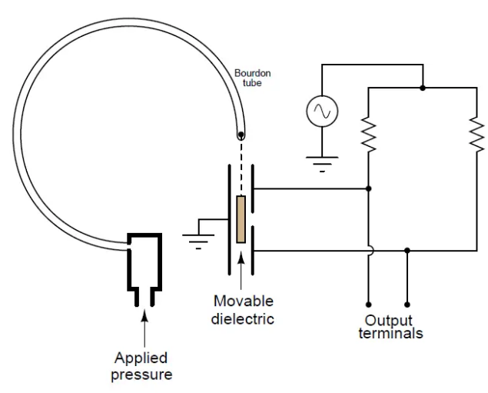

**Strain Gauge Sensors or Piezoresistive sensors**

Piezoresistive means “pressure-sensitive resistance,” or a resistance that changes value with applied pressure.

In order to be practical, a strain gauge must be glued (bonded) on to a larger specimen capable of withstanding an applied force (stress):

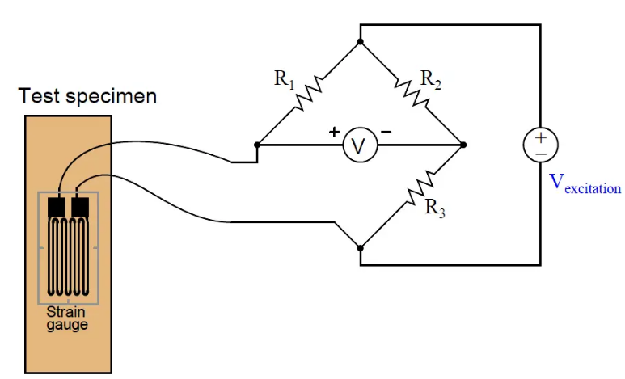

As the test specimen is stretched or compressed by the application of force, the conductors of the strain gauge are similarly deformed. Electrical resistance of any conductor is proportional to the ratio of length over cross-sectional area (R ∝ { l / A } ), which means that tensile deformation (stretching) will increase electrical resistance by simultaneously increasing length and decreasing cross-sectional area while compressive deformation (squishing) will decrease electrical resistance by simultaneously decreasing length and increasing cross-sectional area.

Attaching a strain gauge to a diaphragm results in a device that changes resistance with applied pressure. Pressure forces the diaphragm to deform, which in turn causes the strain gauge to change resistance. By measuring this change in resistance, we can infer the amount of pressure applied to the diaphragm.

The classic strain gauge system represented in the previous illustration is made of metal (both the test specimen and the strain gauge itself). Within its elastic limits, many metals exhibit good spring characteristics. Metals, however, are subject to fatigue over repeated cycles of strain (tension and compression), and they will begin to “flow” if strained beyond their elastic limit. This is a common source of error in metallic piezoresistive pressure instruments: if overpressured, they tend to lose accuracy due to damage of the spring and strain gauge elements.

Modern manufacturing techniques have made possible the construction of strain gauges made of silicon instead of metal. Silicon exhibits very linear spring characteristics over its narrow range of motion, and a high resistance to fatigue. When a silicon strain gauge is over-stressed, it fails completely rather than “flows” as is the case with metal strain gauges. This is generally considered a better result, as it clearly indicates the need for sensor replacement (whereas a metallic strain sensor may give the false impression of continued function following an over-stress event).

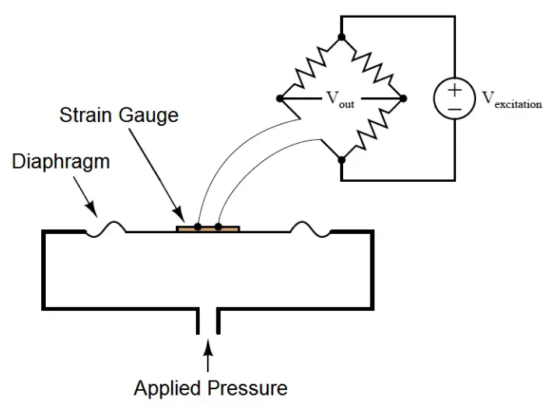

As the diaphragm bows outward with applied fluid pressure, the strain gauge stretches to a greater length, causing its resistance to increase. This change in resistance imbalances the bridge circuit, causing a voltage (Vout) proportional to the amount of applied pressure. Thus, the strain gauge works to convert an applied pressure into a measurable voltage signal which may be amplified and converted into a 4-20 mA loop current signal (or into a digital “fieldbus” signal).

In some designs, a single silicon wafer serves as both the diaphragm and the strain gauge so as to fully exploit the excellent mechanical properties of silicon (high linearity and low fatigue). However, silicon is not chemically compatible with many process fluids, and so pressure must be transferred to the silicon diaphragm/sensor via a non-reactive fill fluid (commonly a silicone-based or fluorocarbon-based liquid). A metal isolating diaphragm transfers process fluid pressure to the fill fluid, which in turn transfers pressure to the silicon wafer. Another simplified illustration shows how this works:

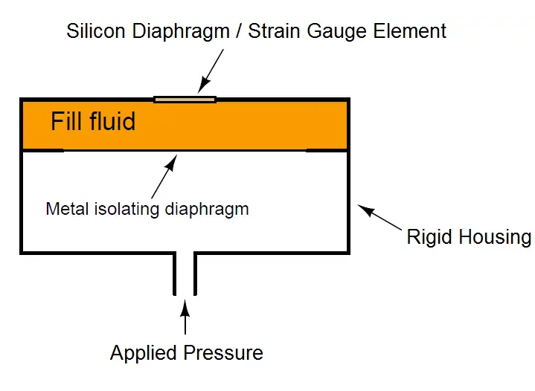

The isolating diaphragm is designed to be much more flexible (less rigid) than the silicon diaphragm, because its purpose is to seamlessly transfer fluid pressure from the process fluid to the fill fluid, not to act as a spring element. In this way, the silicon sensor experiences the same pressure that it would if it were directly exposed to the process fluid, without having to contact the process fluid. The flexibility of the metal isolating diaphragm also means it experiences much less stress than the silicon sensing diaphragm, which avoiding the problems of metal fatigue experienced by transmitter designs using metal as the sensing (spring) element.

This use of a fill fluid to transfer pressure from an isolating diaphragm to a sensing diaphragm inside the transmitter is used in most if not all modern pressure transmitter designs, even those that are not piezoresistive.

#### ****Piezoresistive strain gauge Pressure Transducer****

A conventional piezoresistive strain gauge pressure transducer uses strain gauges bonded to a flexible diaphragm so that any variation in pressure produces a small deformation, or strain, in the diaphragm substance. The deformation alters the strain gauges’ resistance, typically regulated as a Wheatstone bridge, presenting a convenient conversion of the pressure measurement into a practical electrical signal.

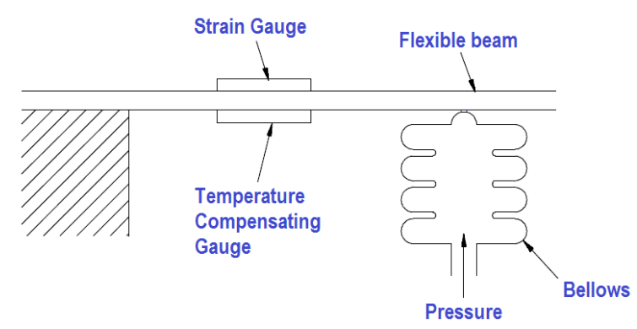

# Capacitive Pressure Sensor

The **Capacitive pressure sensor** operates on the principle that, if the sensing diaphragm between two capacitor plates is deformed by a differential pressure, an imbalance of capacitance will occur between itself and the two plates.

This imbalance is detected in a capacitance bridge circuit and converted to a D.C. output current of [4 to 20 mA](https://instrumentationtools.com/4-to-20-ma-conversion-formula/).

This is shown in Figure, where the movement of a flexible diaphragm relative to a fixed plate is sensed by the capacitance change. A secondary isolating diaphragm is used to protect the sensing diaphragm.

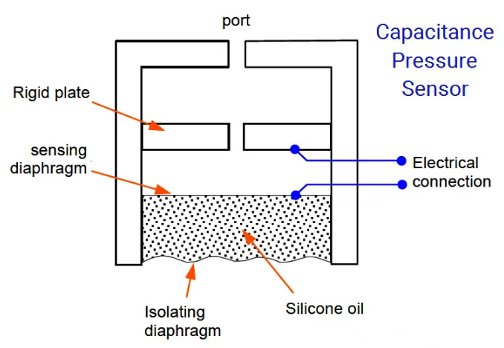

Another type of capacitor uses concentric hollow metal cylinders. The capacitance of this type just like the flat-plate type is proportional to the area.

This principle can be applied to [differential pressure measurement](https://instrumentationforum.com/t/remote-seal-differential-pressure-and-flow-measurements-lrv-and-urv-calculations/5630), as shown in Figure. The pressure acting on the isolating diaphragms set up similar pressures in the silicone oil filling the space between them.

A net force proportional to the difference between the two pressures acts upon the metal sensing diaphragm and deflects it to one side or the other, depending on which input pressure is the greater.

Each plate forms a capacitor with the sensing diaphragm, which is connected electrically to the metallic body transducer.

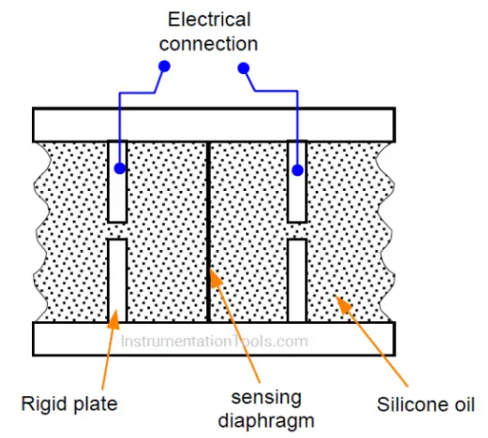

The sensing diaphragm and [capacitor](https://instrumentationtools.com/types-of-capacitors/) thus form a differential variable separation capacitor. When the two input pressure are equal, the diaphragm is positioned centrally and the capacitances are equal.

A difference in the two input pressures causes displacement of the sensing diaphragm and is sensed as a difference between the two capacitances.

This change in capacitance is measured using a bridge circuit to measure the equivalent pressure signal.

# Strain gauge pressure measurement

The [strain gauge](https://automationforum.in/t/what-is-strain-gauge-basics-of-strain-measurement/758) is a passive transducer used to pressure, which converts the change in pressure into a change in resistance as the metal strain gauge deforms because of the pressure applied.

## Principle:

The principle of the strain gauge is the [Piezoresistive effect](https://en.wikipedia.org/wiki/Piezoresistive_effect), which means “pressure-sensitive resistance,” or a resistance that changes value with applied pressure. The strain gauge is a classic example of a piezoresistive element.

Electrical resistance of any conductor is proportional to the ratio of length over cross-sectional area (R ∝ l/A), which means that tensile deformation (stretching) will increase electrical resistance by simultaneously increasing length and decreasing cross-sectional area while compressive deformation (squishing) will decrease electrical resistance by simultaneously decreasing length and increasing cross-sectional area.

The majority of strain gauges are foil type, available in a wide choice and shape and sizes to suit a variety of application.

## Working:

Strain gauges in their infancy were metal wires supported by a frame. Advances in the technology of bonding materials mean that the wire can adhere directly to the strained surface. Since the measurement of strain involves the deformation of metal, the strain material need not be limited to being a wire. As such, further developments also involve metal foil gauges. Bonded strain gauges are the more commonly used type.

There is the [Wheatstone bridge](https://www.electronics-tutorials.ws/blog/wheatstone-bridge.html) arrangement where the change in pressure is detected as a change in the measured voltage:

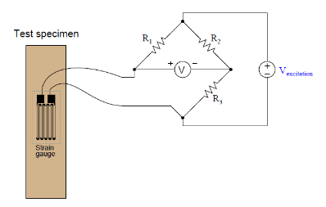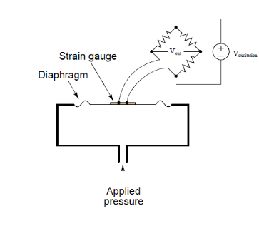

The change in the resistance of the strain gauge breaks the balance of the Wheatstone’s bridge and change the voltage V. The voltage V is proportional to the pressure change in the strain gauge.

Attaching a strain gauge to a diaphragm results in a device that changes resistance with applied pressure. Pressure forces the diaphragm to deform, which in turn causes the strain gauge to change resistance. By measuring this change in resistance, we can infer the amount of pressure applied to the diaphragm.

As strain gauges are temperature sensitive, temperature compensation is required. One of the most common forms of temperature compensation is to use a Wheatstone bridge. Apart from the sensing gauge, a dummy gauge is used which is not subjected to the forces but is also affected by temperature variations. In the bridge arrangement the dummy gauge cancels with the sensing gauge and eliminates temperature variations in the measurement:

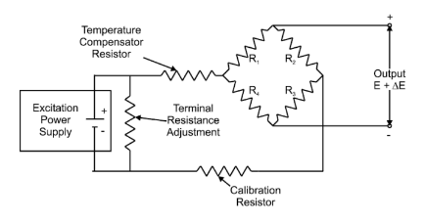

## Applications:

* Residual stress
* Vibration measurement
* Torque measurement
* Strain measurement
* Compression and tension measurement

## Advantages:

* No moving part
* Wide range, 7.5kPa to 1400 Mpa
* Inaccuracy of 0.1%
* Small in size
* Stable devices with fast response
* Good over-range capability

## Disadvantages:

* Unstable due to bonding material
* Temperature sensitive
* Thermoelastic strain causes hysteresis

Ionization Gauge

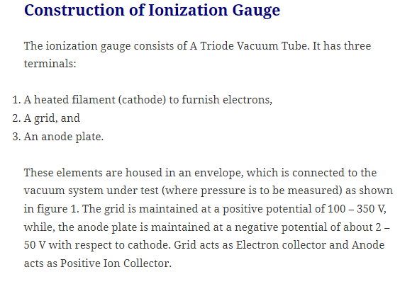

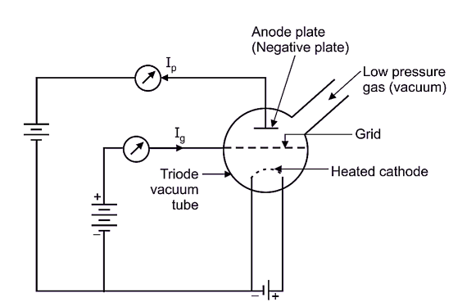

<https://electricalworkbook.com/ionization-gauge/>

What is McLeod Gauge? Working, Diagram, & Applications

# McLeod gauge is a device used for the measurement of very low pressure. McLeod gauge comprises a system of glass tubing, in which, a known volume of gas at unknown pressure is trapped and then isothermally compressed by rising mercury column. This amplifies the unknown pressure and allows its measurement by conventional manometric means. It can measure the pressure of gas, which obeys the Boyle’s law i.e. P1V1 = P2V2.

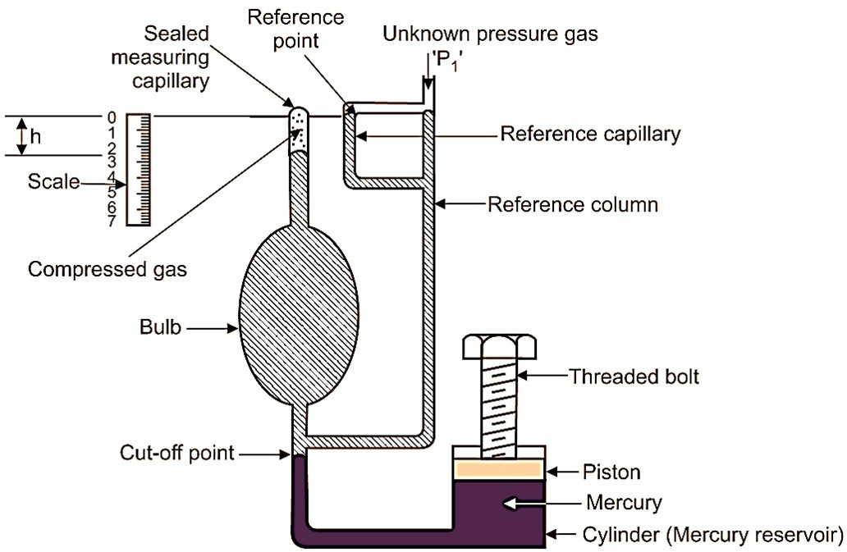

## Working of McLeod gauge

The unknown pressure (P1), which is to be measured, is connected to point as shown in Fig. 1.

**Piston lifted upwards**

Plunger or piston is withdrawn (i.e. lifted upwards) so that, mercury level in all columns and capillaries is lowered. This withdrawal of piston continues till the mercury level gets lowered up to cut-off point. This leads to entry of gas of unknown pressure (P1) into the reference column. At the same time, the gas is admitted into the bulb and sealed measuring capillary. When mercury level is lowered up to cut-off point, then known volume of gas is trapped in the bulb and sealed measuring capillary. Let V1 be the volume of the gas admitted into the bulb and sealed measuring capillary.

This volume V1 is the volume of bulb and sealed measuring capillary above cut-off point, which is known to us.

Piston pushed downwards

# Now, the piston/plunger is pushed downwards in the mercury reservoir/cylinder. Due to this, the mercury level rises above the cut-off point and the gas gets trapped inside the bulb. If the piston/plunger is further pushed downwards, all the gas in the bulb is compressed into the sealed measuring capillary. The plunger motion is continued, until the mercury level in the reference capillary/reference column reaches the zero mark. This zero mark is also called as reference point. This condition of system is shown in the Fig. 1, indicating mercury levels in all the columns/capillaries by shaded area. Under this condition, the compressed gas volume sealed into the measuring capillary can be read directly in terms of height h. This height ‘h’ also represents the rise in gas pressure in terms of height of mercury column. Therefore, if the initial unknown pressure head is P1, then final pressure head will be,

P2 = P1 + h … (1)

Volume of gas entrapped = Cross-sectional area of measuring capillary × h

Thus,

V2 = a × h … (2)

Thus, value of volume ‘V2’ of gas after compression is calculated, by using Equation 1. According to Boyle’s law,

Thus,

P.V = C P1V1 = P2V2

P1V1 = (P1 + h)V2 [From eq. (1)] P1V1 = P1V2+ hV2

P1(V1 – V2) = hV2

P1 = hV2(V1- V2)….(3)

Since, the values of V1, V2 and h are known, we can determine the value of unknown pressure ‘P1’ using equation (3).

# Thus, we say that,

1. For greater amplification ratio, should be large and it can be achieved by,
   * Making the size of bulb as large as possible.
   * Making the Cross-sectional area of capillary as small as possible.
2. Unknown pressure is computed by physical dimensions of instrument; hence it is used to calibrate low pressure gauges.

## Advantages of McLeod Gauge

1. Unknown pressure is calculated ¡n terms of physical dimension of instrument. Therefore, it is used to calibrate low pressure gauges.

# It can be used for pressure measurement of all gases. It is not influenced by composition of gas.

1. It is used as pressure standard ¡n the range from 1 mm of mercury above absolute zero to

0.01 micron with calibration uncertainty of 0.5% to 3%.

1. There is no lower limit to measure low pressure. Any low pressure can be measured.

## Disadvantages of McLeod Gauge

1. It does not give continuous output.
2. It cannot be used, where use of mercury is objectionable.
3. It cannot be used for gases with moisture.

## Applications of McLeod Gauge

1. For Measurement of low pressure.
2. For calibration of low-pressure gauges.



At this condition the force of the piston-weight com- bination is equal to the force of the fluid pressure.

i.e.,

F= PA

Where,

F = PA

And Air

F = Equivalent force of the piston-weight combination

= Mg CM = Total mass, g = Acceleration due to gravity)

P = Fluid pressure

A = Equivalent area of piston-cylinder combination

P = F/A

P= (Mg)/A ...(1)

At equilibrium condition, the pressure developed on the fluid in the chamber is transmitted to the pressure gauge under calibration. The reading then indicated by the pressure gauge is equal to the value of P calculated from equation (1) above.

1. The static calibration of low pressure transducers is carried out by stan- dard mercury or water manometers because these manometers provide accurate measurements of low pressure.

2. Pressure transducers can also be calibrated using secondary standards of pressure such as helical type bourdon gauges made up of quartz and force balance type pressure t transducer.

**Advantages of Dead Weight Tester:**

1. Its construction is simple and is very easy to operate.

2. It is used as a standard for calibration of a wide range of pressure measuring devices.

3. Fluid pressure can be varied easily either by adding pistons or by chang- ing the piston cylinder.

**Disadvantages of Dead Weight Tester:**

1. Friction between the piston and cylinder affects the accuracy of the gauge.

2. The gravitational force also affects the accuracy of the gauge.

**Applications of Dead Weight Tester:**

It is used to measure pressure and also to calibrate all kinds of pressure gauges.

**Factors Affecting the Accuracy of Dead Weight Tester:**

The following are the factors affecting the accuracy of dead weight tester,

1. The presence of friction between the piston and the cylinder. 2. Uncertainties in the value of gravitational constant.

3. Ambiguous value of effective area of piston cylinder.

4. Gravity

5. Mass, height and air buoyancy

6. Head of transmitting fluid

8. Thermal expansion

9. Weight of the fluid buoyancy

7. Elastic deformation of piston and cylinder