**Module II**

Accelerometers: LVDT, piezoelectric, strain gauge and variable reluctance type accelerometers – Mechanical type vibration instruments – Seismic instrument as an accelerometer and vibrometers – Calibration of vibration pickups.

**Measurement of Acceleration**

**Strain gauge type Accelerometer**

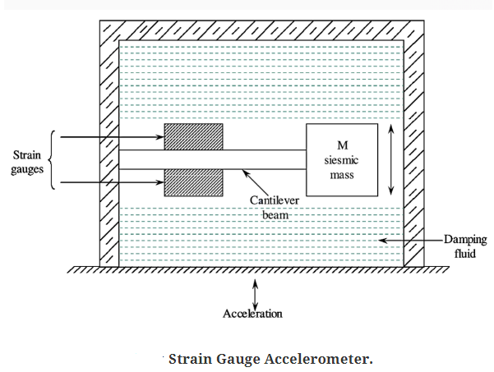

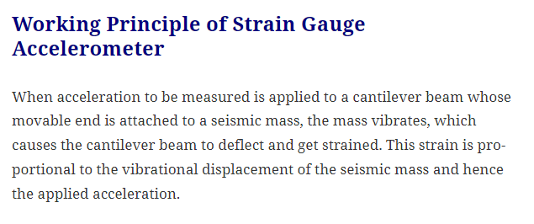

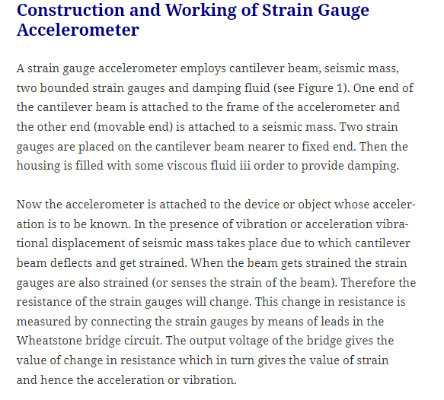

**LVDT Accelerometer**

The LVDT accelerometer consists of one primary winding and two secondary windings having an equal number of turns. Between the primary and two secondary windings, a core is placed which acts as a sensing mass. This core is connected to the housing of the accelerometer by means of two flexible reeds.

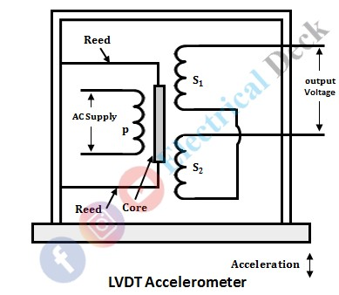

When the acceleration to be measured is applied, vibrational displacement of core takes place due to which differential output voltage will be produced (at the output of LVDT). This output voltage gives the measure of acceleration.

### Working of LVDT Accelerometer:

The accelerometer is attached to the object whose acceleration is to be measured. In the presence of acceleration, the vibrational displacement of the core occurs. Depending on acceleration the core moves up and down with respect to two secondaries.

Therefore, an differential output voltage will be generated at the output terminals. The magnitude of induced voltage (i.e., the differential output voltage of two secondaries) is proportional to the displacement of core and hence, gives the amplitude of vibration (i.e., acceleration).

### Advantages of LVDT Accelerometer:

#### They have good resolution.

#### They offer very low resistance to the displacement of sensors compared to potentiometers.

#### They can be used to measure high-frequency vibrations.

**Piezoelectric Accelerometer:**



The piezoelectric accelerometer is based on a property exhibited by certain crystals where a voltage is generated across the crystal when stressed. This property is also the basis for such familiar sensors as crystal phonograph cartridges and crystal microphones. For accelerometers, the principle is shown in Figure . Here, a piezoelectric crystal is spring-loaded with a test mass in contact with the crystal. When exposed to an acceleration, the test mass stresses the crystal by a force *(F* = *ma),* resulting in a voltage generated across the crystal. A measure of this voltage is then a measure of the acceleration. The crystal per se is a very high-impedance source, and thus requires a high-input impedance, low-noise detector. Output levels are typically in the millivolt range. The natural frequency of these devices may exceed 5 kHz, so that they can be used for vibration and shock measurements.

**Seismic Acceleration Pickups**

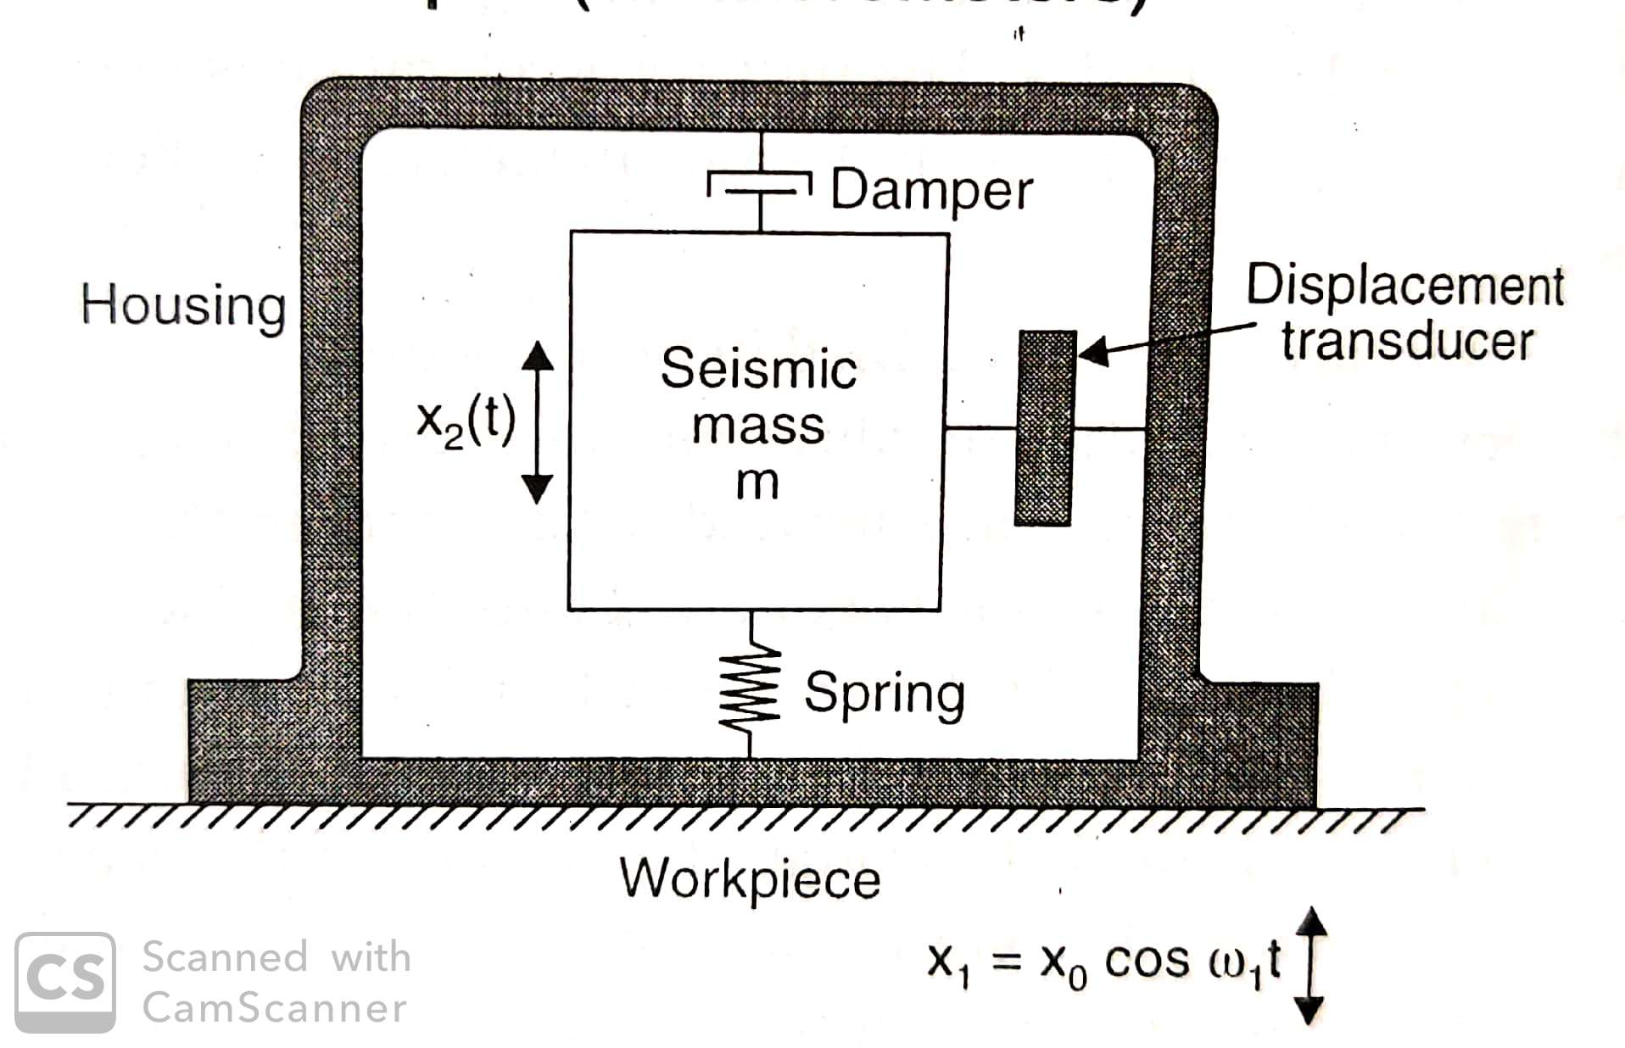

The seismic instrument is a device with spring-mass damper system as shown in the figure. The mass is connected through the parallel spring and damper arrangement to the housing frame. This frame is then connected to the vibration source whose characteristics are to be measured. The mass tends to remain fixed in its spatial position, so that the vibration motion is registered as a relative displacement between the mass and the housing frame. The displacement is then sensed and indicated by an appropriate transducer. The seismic instrument may be used for either displacement or acceleration measurement by proper selection of mass, spring and damper combinations. In general, a large mass and soft spring are desirable for vibrational