**Module I**

**Load Cells**

[**Load cells**](https://tacunasystems.com/product-category/load-cells/) are precision force measuring instruments. They offer a relatively low-cost, durable, and easy-to-install solution to almost any load measurement need. Load cells have been providing quality measurements in aerospace, agriculture, medicine, industrial weighing and many other applications for decades. Ongoing advancements in load cell technology have further broadened their use.

A load cell is a [**transducer**](https://tacunasystems.com/knowledge-base/force-measurement-glossary/#force-transducer)or sensor that converts the kinetic energy of a force into a quantifiable output such as an electrical signal. Each type exploits some physical property of its component materials to create this measurable output. The strength of the output is proportional to the force (compression, tension, pressure, etc.) applied to the load cell. This output data can then be displayed, stored, or used to control complex systems. Note that without this energy conversion, a force would be impossible to measure, so load cells serve a very important function.

Load cells are most commonly used in industrial weighing applications such as scales. Because load cells can convert forces to electrical signals, they are also often used in control systems where the force on a system affects its behavior. For example, a load cell may measure the tension on a machine that winds cabling on a spool to ensure the system uses a consistent tension throughout its process.

Fundamentally, load cells are in systems that test, monitor, and run industrial machinery, medical devices, aircraft loads, and many other applications.

**Types of Load Cells**

Several types of load cells exist for varying applications:

* [**Strain Gauge Load Cells**](https://tacunasystems.com/knowledge-base/an-overview-of-load-cells/#strain-gauge-load-cells)
* [**Hydraulic Load Cells**](https://tacunasystems.com/knowledge-base/an-overview-of-load-cells/#hydraulic-load-cells)
* [**Pneumatic Load Cells**](https://tacunasystems.com/knowledge-base/an-overview-of-load-cells/#pneumatic-load-cells)
* [**Capacitive Load Cells**](https://tacunasystems.com/knowledge-base/an-overview-of-load-cells/#capacitive-load-cells)
* [**Piezoelectric Transducers**](https://tacunasystems.com/knowledge-base/an-overview-of-load-cells/#piezoelectric-transducers)
* **Magneto Elastic Cell**

### Strain Gauge Load Cells

Strain gauge load cells are the most common. Unlike the hydraulic and pneumatic designs described below that convert pressure differentials to measurements, the strain gauge load cell operates through changes in electrical resistance.

Inside each strain gauge load cell is at least one strain gauge device. A strain gauge is a thin wire etched in a back-and-forth pattern onto a non-conductive substrate material with connectors at each end of the wire. The strain gauge functions on the elastic properties of the wire; that is, when a wire is stretched, its length increases and cross section decreases, and when compressed, the opposite occurs. In the tension case, the resistance of the wire will increase, while in the compression case, the resistance of the wire will decrease.

#### Strain Gauge Load Cell Components

Strain gauge load cells consist of:

* A loading platform or system to apply the force,
* One or more strain gauges
* An excitation voltage source
* Output wires to measure a change in voltage caused by the change in resistance of the strain gauges

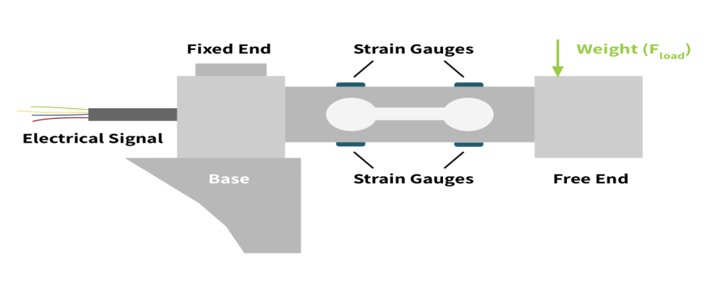

Figure shows a single end beam load cell with these components. The strain gauges at the top of the beam are in tension under the load, while those at the bottom are in compression under the load.

#### Features, Benefits and Disadvantages of Strain Gauge Load Cells

Strain gauge load cells are the most popular due to their high accuracy, low price point, and general ease of use. They have a high frequency response for dynamic loads and are not sensitive to temperature variations. Because they can fit into a wide variety of load-mounting configurations, they lend themselves to almost any industrial application.

Strain gauge load cells are passive transducers meaning they require an excitation voltage to operate. This can restrict their use in areas of limited electrical supply or in areas where ignition may be an issue.

### Hydraulic Load Cells

Hydraulic load cells convert a load to hydraulic pressure. The measured load is applied to a load platform attached to a piston. The piston sits in a closed chamber filled with fluid. When a load is applied, the action of the piston on the diaphragm pressurizes the liquid. The change in liquid pressure is directly proportional to the force applied by the load. This liquid pressure is readable through an attached bourdon tube pressure gauge.

#### Hydraulic Load Cell Components

Hydraulic load cells have the following components:

* An elastic diaphragm
* A piston connected to a load platform
* Hydraulic fluid which is usually oil or sometimes water
* Pressure gauge or gauges
* A tube connecting the chamber to the pressure gauge
* Steel housing for the assembly

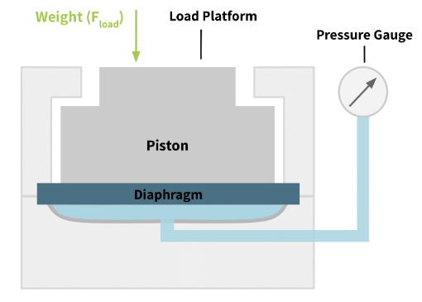

#### Features, Benefits and Disadvantages of Hydraulic Load Cells

Because the hydraulic load cell design contains no electrical components, this type of load cell lends itself to environments where explosion safety is a concern, or where an outside power source may be difficult to provide.

On the flip side, hydraulic load cells tend to be more expensive than other types, making them cost-prohibitive for certain applications. Hydraulic load cells can typically measure up to 5MN and have an accuracy of about 0.25 to 1.0 percent of [**full-scale output**](https://tacunasystems.com/knowledge-base/force-measuement-tips/force-measurement-glossary/#full-scale-output). Their resolution is typically about 0.02 percent. Because these load cells are sensitive to ambient pressure, the user must reset the readout to zero before each use.

### Pneumatic Load Cells

Pneumatic load cells function similarly to their hydraulic counterparts in that they convert fluid pressure into a load measurement. However, the pressurized fluid in a pneumatic load cell is a type of gas, oftentimes air.

The force to be measured is applied to a loading platform on one side of a diaphragm, and a pressure supply regulator introduces a pressurized gas to a chamber on the opposite side of the diaphragm to balance out the force. A nozzle connected to a pressure gauge allows some of the pressurized gas to escape the chamber. The pressure of the gas flowing through this nozzle is measured. This pressure is proportional to the force applied.

#### Pneumatic Load Cell Components

Pneumatic load cells have the following components:

* A loading platform to apply the force
* A steel chamber filled with pressurized gas or air
* An elastic diaphragm connected to the loading platform that seals the chamber
* An air supply regulator
* Nozzle (bleed valve)
* Pressure gauge

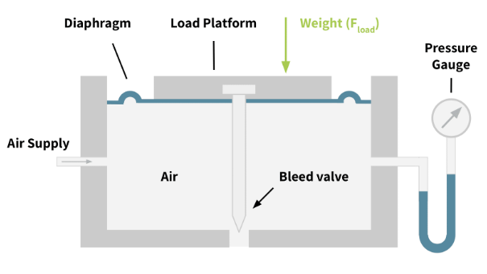

#### Features, Benefits and Disadvantages of Pneumatic Load Cells

Like their hydraulic counterparts, pneumatic load cells are explosion resistant and are generally used in applications with intrinsic safety concerns. The pneumatic load cell is also tolerant of temperature changes. Finally, this type of load cell is sensitive to small loads. This makes them practical for systems requiring real-time accuracy with the lightest of loads, such as dispensing IV fluids.

### Capacitive Load Cells

Capacitive load cells operate on the ability of a material or system to store a charge. They consist of two parallel plates with a gap between them. An electric current is supplied to the plates until a stable charge forms on each: one with a positive charge and the other negative. When a load is applied to one of the plates, the gap narrows causing a stored charge (or capacitance) between the plates. This charge creates the output of the load cell, which is then translated to a load measurement.

#### Capacitive Load Cell Components

Capacitive load cells consist of:

* A loading platform external to the housing to apply the force
* An insulated housing containing a free moving and a fixed plate
* A [**dielectric**](https://tacunasystems.com/knowledge-base/force-measurement-tips/force-measurement-glossary/#dielectric)material between the plates (which may be air)
* Electrical wires to the plates
* A rigid rod or connector between the loading platform and the free moving plate in the housing

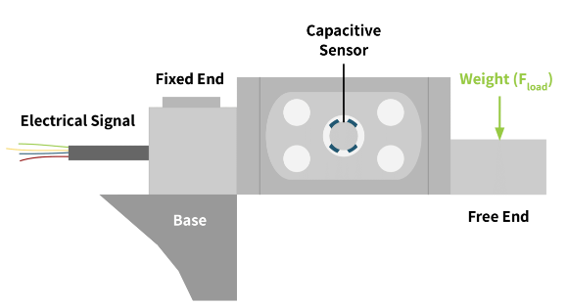

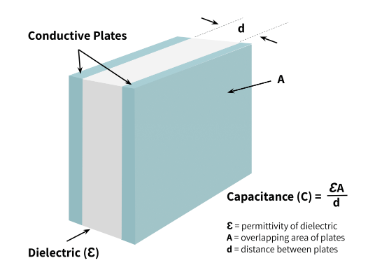

#### Features, Advantages and Disadvantages of Capacitive Load Cells

Capacitive load cells are highly sensitive and accurate over a wide range of forces, large and small. They are also rather simple in design, making them more cost-effective than other load cell types. Their ability to be hermetically sealed without compromising their operation makes them a good choice for food and medical weighing applications where hygiene is an issue.

Because capacitive load cells operate using an electric charge they may not be a good choice in flammable environments. Also, some dielectric materials are sensitive to temperature, which can affect the accuracy of the load cell.

### Piezoelectric Transducers

Piezoelectric sensors operate based on the [**piezoelectric effect**](https://tacunasystems.com/knowledge-base/the-piezoelectric-effects-and-its-applications/). The piezoelectric effect is a natural property of materials such as quartz crystal and other ceramics.

Piezoelectricity is produced when this polarized crystalline material is stressed or deformed. The stress then causes a shift in the orientation of the internal dipoles of the material. It is similar to di-electricity, which occurs when a charge develops from a shift of electrons in an insulator. Piezoelectric sensors can quantify force, pressure, and displacement. Metallic electrodes bonded to the surface of the material form a measurable net charge. For proper function, the design must place these electrodes perpendicular to the applied force.

Both [**compression**](https://tacunasystems.com/knowledge-base/force-measurement-tips/force-measurement-glossary/#compression-force)and [**tension**](https://tacunasystems.com/knowledge-base/force-measurement-tips/force-measurement-glossary/#tensile-force)forces create this piezoelectric effect. Compression forces create an opposite polarity to tension forces. The output voltage is directly proportional to the applied force.

#### Piezoelectric Transducer Components

Piezoelectric load cells consist of:

* A loading platform or system to apply the force
* Metallic electrodes bonded to the piezoelectric material
* The piezoelectric material
* Output wires to measure a change in voltage caused by the change in charge

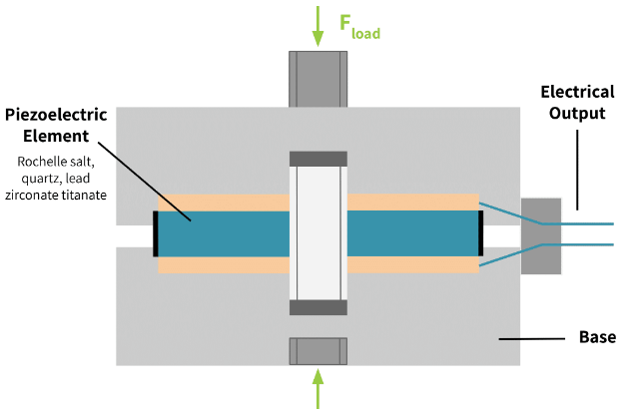

#### Features, Benefits and Disadvantages of Piezoelectric Transducers

A piezoelectric transducer is an active transducer, meaning it does not require an external power source to generate an output signal. This characteristic makes this device desirable in applications where an external power source is inconvenient. However, its output signal does require amplification as it is very small.

The piezoelectric effect happens for dynamic forces. Once a force becomes static, the output of the sensor returns to zero. Therefore these transducers lend themselves to applications requiring the measurement of a transient force.

Piezoelectric transducers are more durable than other load cells, and have a high frequency response.

**MAGNETO – ELASTIC LOAD CELL**

**PRINCIPLE:**

Magneto-elastic load cell works in principle of “Magneto elastic principle” called as Villari effect.

“When a ferromagnetic material undergoes a mechanical stress, it changes the magnetic permeability of the material. The level of change in permeability property is proportional to applied force / stress.”

Depends on permeability property of magnet defined as “The measure of the ability of a material to support formation of magnetic field within itself”.

**CONSTRUCTION & WORKING:**

* Magneto-elastic load cell is also called as “Pressductor”.
* The laminated sheets of ferromagnetic material bonded together to form transducer body.
* Primary and secondary windings are wounded at right angles through the holes as shown in block diagram.
* When AC current is supplied to primary windings, secondary windings remain undisturbed under no load condition.
* On load condition the angle between the primary and secondary changes from 0 to degree and when load is applied at at 45 degree the resulting flux linkage is given by

Ф=αB cosθWhere α = Cross Sectional Area of material 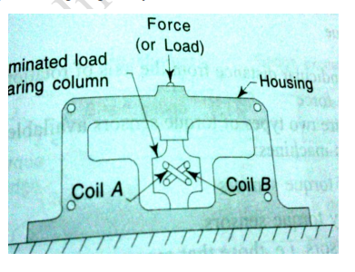

Ф = Total flux linkage

B= Magnetic flux density

cosθ = change in angle

if n = n2/n1 = turn ratio

es= -n dФ /dt

**TORQUE MEASUREMENT**

**TORQUE:**

* “The force which tends to change the linear motion or rotation of a body”.
* “It is also defined as the turning or twisting moment of a force about an axis”.
* “The force that tends to cause rotation”

Unit: Radian /sec

T= FD

Where T=Torque

F=Force

D=perpendicular distance from the axis of rotation of the line of action of the force

**METHODS OF MEASUREMENT:**

* strain gauge (In-Line Rotating torque sensor)
* Relative angular twist. (Proximity torque sensor)
* Magnetic pick up type
* Optical stroboscopic type
* In-Line stationary torque sensor.

**Strain Gauge Type Torque Measurement**

**PRINCIPLE:**

When a strain gauge is stretched its resistance will change. The change in resistance is proportional to applied torque. Due to unbalance in bridge (change in resistance) an A.C voltage is developed in output side.

When torque is applied to shaft, there will be twist in shaft in turn which changes the dimension of strain gauge that results in change in resistance. The change in resistance will be proportional to the applied toque.

**CONSTRUCTION & WORKING:**

A strain gage can be installed directly on a shaft. Because the shaft is rotating, the torque sensor can be connected to its power source and signal conditioning electronics via a slip ring. The strain gage also can be connected via a transformer, eliminating the need for high maintenance slip rings. The excitation voltage for the strain gage is inductively coupled, and the strain gage output is converted to a modulated pulse frequency (Figure 6-5). Maximum speed of such an arrangement is 15,000 rpm. Strain gages also can be mounted on stationary support members or on the housing itself. These "reaction" sensors measure the torque that is transferred by the shaft to the restraining elements. The resultant reading is not completely accurate, as it disregards the inertia of the motor. Strain gages used for torque measurements include foil, diffused semiconductor, and thin film types. These can be attached directly to the shaft by soldering or adhesives. If the centrifugal forces are not large--and an out-of-balance load can be tolerated--the associated electronics, including battery, amplifier, and radio frequency transmitter all can be strapped to the shaft.

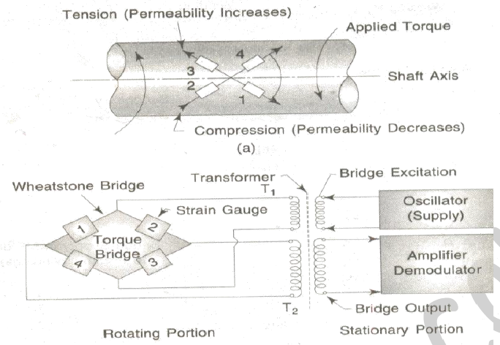

**Torque measurement by relative angular twist method**

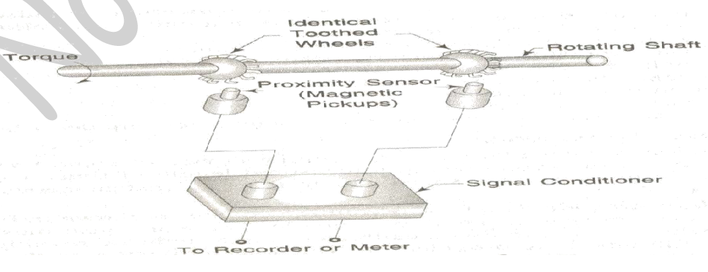

Proximity and displacement sensors also can detect torque by measuring the angular displacement between a shaft's two ends. By fixing two identical toothed wheels to the shaft at some distance apart, the angular displacement caused by the torque can be measured. Proximity sensors or photocells located at each toothed wheel produce output voltages whose phase difference increases as the torque twists the shaft.

**SPEED MEASUREMENT**

Speed is defined as rate of change of position of an object with respect to time.

**Units of speed**

* Meters per second (symbol m s−1 or m/s), the SI derived unit;
* Kilometers per hour (symbol km/h);
* Miles per hour (symbol mph);
* Knots (nautical miles per hour, symbol kn or kt);
* Feet per second (symbol fps or ft/s);
* Revolution per minute (rpm)

**Measuring methods:**

Generally speed is calculated using tachometers which calculates the angular speed in revolution per minute (rpm) of the object and converted into the form required Types of Tachometer:

1. Mechanical tachometer: Associated only with mechanical units to measure speed

2. Electrical tachometer: Associated with transducer for converting rotational speed to electrical quantity

The mechanical tachometer measures the speed of shaft regarding revolution per minutes.

The electrical tachometer converts the angular velocity into an electrical voltage. The electrical tachometer has more advantages over the mechanical tachometer. Thus it is mostly used for measuring the rotational speed of the shaft. Depends on the natures of the induced voltage the electrical tachometer is categorized into two types.

* AC Tachometer Generator
* DC Tachometer Generator

**DC Tachometer Generator**

Permanent magnet, armature, commutator, brushes, variable resistor, and the moving coil voltmeter are the main parts of the DC tachometer generator. The machine whose speed is to be measured is coupled with the shaft of the DC tachometer generator.

The DC tachometer works on the principle that when the closed conductor moves in the magnetic field, EMF induces in the conductor. The magnitude of the induces emf depends on the flux link with the conductor and the speed of the shaft.

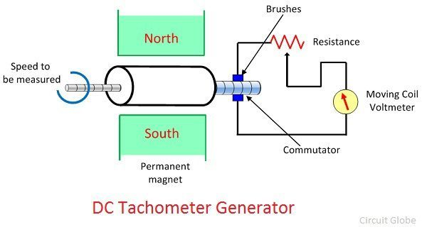

The armature of the DC generator revolves between the constant field of the permanent magnet. The rotation induces the emf in the coil. The magnitude of the induced emf is proportional to the shaft speed.

The commutator converts the alternating current of the armature coil to the direct current with the help of the brushes. The moving coil voltmeter measures the induced emf. The polarity of the induces voltage determines the direction of motion of the shaft. The resistance is connected in series with the [voltmeter](https://circuitglobe.com/voltmeter.html) for controlling the heavy current of the armature.

The emf induces in the dc tachometer generator is given as

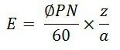

Where,

E generated voltage  
Φ – flux per poles in Weber  
P- number of poles  
N – speed in revolution per minutes  
Z – the number of the conductor in armature windings.  
a – number of the parallel path in the armature windings.

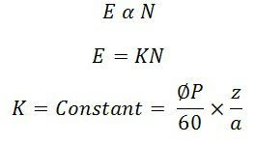

### Advantages of the DC Generator

The following are the advantages of the DC Tachometer.

* The polarity of the induces voltages indicates the direction of rotation of the shaft.
* The conventional DC type voltmeter is used for measuring the induces voltage.

### Disadvantages of DC Generator

* The commutator and brushes require the periodic maintenance.
* The output resistance of the DC tachometer is kept high as compared to the input resistance. If the large current is induced in the armature conductor, the constant field of the permanent magnet will be distorted.

**AC Tachometer Generator**

The DC tachometer generator uses the commutator and brushes which have many disadvantages. The AC tachometer generator designs for reducing the problems. The AC tachometer has stationary armature and rotating magnetic field. Thus, the commutator and brushes are absent in AC tachometer generator.

The rotating magnetic field induces the EMF in the stationary coil of the stator. The amplitude and frequency of the induced emf are equivalent to the speed of the shaft. Thus, either amplitude or frequency is used for measuring the angular velocity.

The below mention circuit is used for measuring the speed of the rotor by considering the amplitude of the induced voltage. The induces voltages are rectified and then passes to the capacitor filter for smoothening the ripples of rectified voltages.

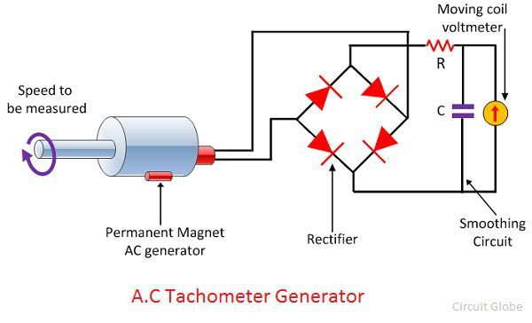

### Advantages

* The drag cup Tachogenerator generates the ripple free output voltage.
* The cost of the generator is also very less.

### Disadvantage

The nonlinear relationship obtains between the output voltage and input speed when the rotor rotates at high speed.

**CAPACITIVE TACHOMETER:**

**PRINCIPLE:**

**Capacitor – charges & discharges.**

* The principle of charging a capacitor and discharging through a meter continuously.
* If charging and discharging is controlled by speed of the device which is to be measured, then the average discharge current would be proportional to the speed.
* Average discharge current (I) is given by **I = RCω**

Where, **R** – resistance, **C** – capacitance, **ω** - speed of rotation (rpm)

**CONSTRUCTION & WORKING:**

* The circuit diagram for capacitive tachometer is shown below.
* The **circuit diagram 1** is used to measure the rotational speed.
* The **circuit diagram 2** is used to measure the direction of rotation along with rotational speed.
* It consist of a capacitor (C), rotary switch with rotary positions P1 and P2, a milli ammeter to indicate the discharge current, power supply (E), resistor (R).
* The capacitor is charging when the rotary switch is in position P1, and due to rotation the rotary switch will go to position P2 where discharging of current takes place through ammeter.
* This mechanism is repeated as rotation takes place continuously. Thus the charging and discharging activity depends on the speed of rotation of the device.
* Thus discharging current indicates the average speed of the device, average discharge current (I) (**I) = RCω**
* Measurement of direction of rotation along with rotational speed is possible (diagram 2) when the direction of rotation reverses, the direction of current also gets changed since the polarity of capacitor changes.
* The range of instrument can be changed by changing the range supply voltage and capacitor.

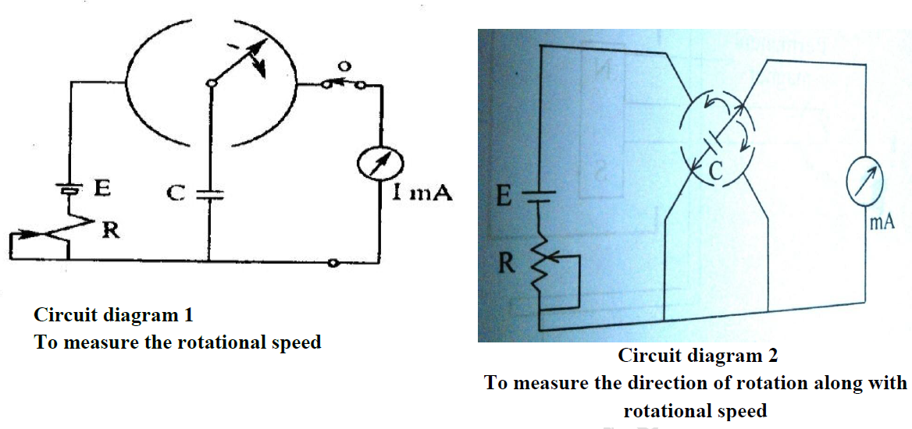

**EDDY CURRENT / DRAG CUP TYPE / MAGNETIC DRAG TACHOMETER**

**PRINCIPLE:**

“An emf is induced due to change in magnetic flux”

An analog signal is produced in form of continuous drag due to eddy current induced in the cup which is proportional to speed.

**CONSTRUCTION & WORKING:**

* The diagram for drag cup type tachometer is shown below.
* A permanent magnet is connected to the shaft whose speed is to be measured.
* An Aluminium disc or drag cup is fixed closer to rotating magnet.
* The drag cup is self-possessed by a control spring and pointer arrangement as shown in diagram.
* Due to angular rotation of shaft, the magnet also rotates continuously. Thus the magnetic flux cuts the drag cup and in turn emf is produced.
* The emf generates an eddy current in the drag cup. This eddy current oppose the magnetic flux and a torque is produced which tend to drag or rotate the drag cup along the rotation of magnet.
* Due to this action the angular rotation is indicated by the pointer via spring setup which is proportional to angular speed (**ω**).

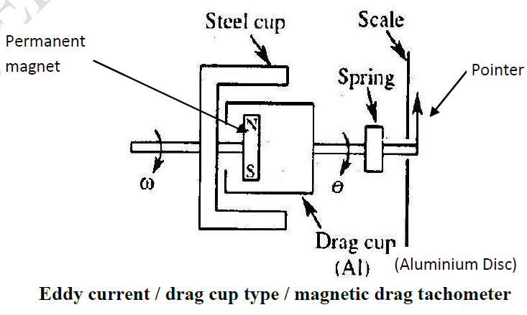

**STROBOSCOPE**

**PRINCIPLE:**

A stroboscope having a scale that reads in flashes per minute or in revolutions per minute; the speed of a rotating device is measured by directing the stroboscopic lamp on the device, adjusting the flashing rate until the device appears to be stationary, then reading the speed directly on the scale of the instrument.

**CONSTRUCTION:**

* Stroboscopes are simple, portable manually operated device used to measure the speed of rotation or frequency of vibration of a mechanical system.
* Used to measure periodic or rotary motions without making contact with rotating body or disturbing the equipment under test.
* A stroboscope, also known as a strobe, is an instrument used to make a cyclically moving object appear to be stationary. The principle is used for the study of rotating, reciprocating, oscillating or vibrating objects.
* The frequency is set by operator. The speed is measured by adjusting the frequency so that the moving objects are visible only at specific intervals of time.
* The most advanced stroboscopic instruments for industrial use are of the electronic type. They consist of an oscillator that controls the pulse frequency and of a gas-discharge tube that serves as the source of the light pulses.
* The shaft doesn't stop turning, but the strobe flashes and it illuminates the same spot on the shaft with every rotation, and that's what makes it (the shaft) appear to stop moving.
* If the strobe is flashing at exactly half the speed of the shaft, it will be illuminating the same spot on the shaft each time it flashes, but the shaft will actually have turned twice instead of once.
* The frequency of the oscillator and, consequently, of the flashes can be smoothly adjusted by varying the parameters of the electric circuit, usually between 2 and 2,500 Hz with accuracy rate - 1 to 2%.

**Source of light:**

* An electronic stroboscope uses a (variable frequency flashing light) multivibrator type circuit to produce flashes of light at known and adjustable rates.
* The variable frequency flashing light source is called **strobotron**.
* Neon lamps or light emitting diodes are commonly used for low-intensity strobe applications, Neon lamps were more common before the development of solid-state electronics, but are being replaced by LEDs in most low-intensity strobe applications.
* Xenon flash lamps are used for medium- and high-intensity strobe applications. Sufficiently rapid or bright flashing may require active cooling such as forced-air or water cooling to prevent the xenon flash lamp from melting.

**WORKING: (to measure rotational speed)**

* A simple stroboscope circuit is shown below.
* A distinctive mark is made on the shaft whose rotational speed is to be measured.
* A stroboscope is made to flash directly on the mark. The flashing is adjusted until the mark appears stationary even though the shaft rotates.
* At this condition, the speed of shaft (n in rpm) is equal to frequency (f in Hertz) of light flashed on shaft. i.e., n = f

In general, if no. of marking in shaft is „m‟, then n = f/m. If no. of marking is 1, then n = f

* If no. of marking is 2, then n = f/2
* If no. of marking is 3, then n = f/3

Typically a gas-discharge or solid-state lamp is used, because they are capable of emitting light nearly instantly when power is applied, and extinguishing just as fast when the power is removed.

**Advantage:**

* Used to measure periodic or rotary motions without making contact with rotating body or disturbing the equipment under test.
* Mechanical equipment may be observed under actual operating conditions with the aid of stroboscopes.
* Parasitic oscillations, flaws, and unwanted distortion at high speeds are readily detected.
* The flashing-light stroboscopes employ gas discharge tubes to provide a brilliant light source of very short duration.

